UNIVERSITY OF SCIENCE AND TECHNOLOGY OF HANOI
UNDERGRADUATE UNIVERSITY



Group Project

Plankton Classification Platform for Supporting Research Activities of Environmental Scientists

Report 2

Submitted by
LE Nguyen Khoi | USTHBI7-086
NGUYEN Xuan Bach | USTHBI7-021
LE Minh Anh | USTHBI7-007
DOAN Thanh Huy | USTHBI7-084
PHAM Minh Duc | USTHBI7-041

Under the guidance of:
Dr. NGHIEM Thi Phuong | ICT Lab

Hanoi, January 2019

TABLE OF CONTENT

- Introduction
Plankton is a diverse group of organisms that live in the oceans and cannot swim against the water current [1]. And they have an important role to ecosystem and human life that we cannot undeniable. The carbon cycle of the Earth is almost controlled by these tiny organisms. In order to study plankton’s population that is imbalance nowadays because of the ecosystem changed. Underwater camera systems are used to capture microscopic, high–resolution images of plankton over large study areas. However, there are a huge amount of plankton images, it’s raises a key question that how we can analyze the collected plankton images in order to assess the population and distribution of plankton species. A natural approach to this question is to manually classify collected plankton images for further human analysis This approach, however, is infeasible since it would be extremely time and cost consuming to manually classify millions of images [2].
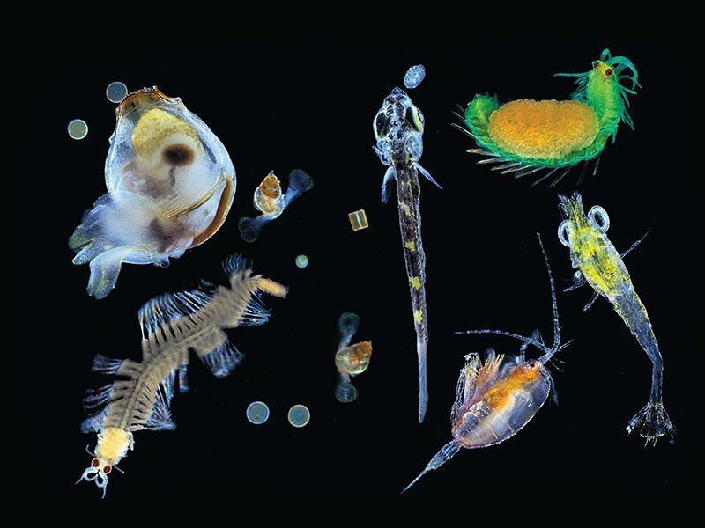
- Context of Project
To overcome this problem, the project has two main goals:
- To develop a classification platform to automatically put new plankton images in their correct categories;
- To build a plankton website so that the environmental scientists can contribute plankton data for easier use of plankton images in research and education.
- Main Question
When we were doing our project, there are a lot of questions that come up to us. However, there is a question that our team care most is “Is our website can automatically detect new kind of plankton and tag it to a group in gallery when people upload to website’s data?”
This question come up when we very worry about what if the website can only detect the image from a type of plankton that we had put in the train model, when we are doing the project. Will it detect the new plankton or they will they the new plankton is just some kind of random image come up. We still thinking a about that problem for the time being. And not yet find the answer.
- Aims and Objectives
- Aims:
- This project is about making a website using knowledge that we learned in the university.
- To develop teamwork skill with the use of tools like Github and Google Doc.
- To learn process of making a project.
- Build a groundwork that can be reused and expanded in the future.
- Understand the basic background about machine learning and image classification.
- Successfully build and develop a part of website that image can be upload to website data, and website can detect that image belong to which type of plankton.
- Objectives:
- Apply image classification models for the case of big datasets.
- Apply image classification models to build plankton classification platform.
- Develop web user interface for environmentalist to use plankton classification platform and let people also can contribute plankton data for easier use of plankton images in research and study

- Literature Review
Nowadays, there are many kinds of methods in the literature to classify plankton around the internet. One of them that we can not discuss about is an automated platform for classifying and monitoring phytoplankton that using scanning flow cytometer. This cytometer was designed to analyze the natural properties of plankton. For example, the cytometer is capable of analyzing from small to large planktonic particles (from 1 to 700 μm in diameter and a few mm in length) and relatively large water volumes. The platform manipulates and visualizes data using R programming language. The datasets also include original sampled volume, date, time, and depth at which particles were taken.
This platform was proposed by pomati et al, 2011 [3]. With the idea of a platform that it is able to extract very detail information of planktonic particles for further analysis is very interesting. However, if students or researchers want to have a large amount of plankton datasets for large-scale studies, the platform shows the limit in gaining high efficiency to classify the plankton. This is because the platform has not yet taken into account the advanced data analysis techniques to handle big datasets. So to solve the problem difficult use of plankton images for research and education, we come up with an idea that we create a website, an online plankton analysis system (PAS) for environmentalist to use plankton classification platform. Basically, the system is a web application allowing marine biologists to classify their plankton images using a web user interface. PAS provides the functions for experts to upload their images, process them, extract features, hand-label image, train classifiers, and use those classifiers to automatically label new images [4]. So that people can contribute plankton data in order to help other people want to research and study. And to make thing much easier than pomati et al, 2011 [3] platform by we apply the modern machine learning methods to our website, namely convolutional neural network, in order to gain high performance computing when analyzing large datasets.

- Scientific Methods
From what we mentioned above that our motivation in this work is to build a classification platform to put new plankton images into their correct categories. In the following, we will present in detail the machine learning methods we use to perform this motivation.
- Machine learning and image classification
According to Michalski et al, 2013 [5] machine learning is a field of study that provides computers with ability to learn from experience. To the detail, that we talked about that a computer program is said to learn from experience if it can teach itself to grow and change having new data. With the detail, we can tell that machine learning focuses on the development of computer algorithms for transforming data into appropriate action. For example that make it easier to understand how the machine learning environment work. In the environment, there are available data, statistical models and computing power are simultaneously interacted with each other. As a result from that, growth in data causes the need of additional computing power, which in turn spurs the development of statistical method for analyzing large datasets. This make it become a loop cycle of advancement allowing even larger and more interesting data to be collected.
Image classification refers to the task of classifying images into appropriate classes or categories that they belong to. In other wod, we can say that image classification algorithms perform the press of putting unlabeled images into their class, type or categories that they belong to.
In the following, we will present our study on the machine learning models - convolutional neural network as the image classification models.
2. Image classification models - Convolutional Neural Network.
Convolutional Neural Networks (CNN) is a variant of multilayer perceptron (MLP) introduced by LeCun et al, 1998 [6] to overcome the weakness of MLP. To the detail, like we had mentioned above, it is wasteful to connect each neuron in a hidden layer to only a local region of the input layer. This connection is executed by using a convolution filter over the input layer and the hyper-parameter of such region is called the receptive field of the neuron. The convolution filters act as local filters over the input space and are well-suited to exploit the strong spatially local correlation in the natural images.
3. Web user interface
Since our primary aimed like we mentioned on the title plankton classification platform for supporting research activities of environmental scientiests

References:
[1] Castro Pond, Stephen, and George L. Pickard. Introductory dynamical oceanography. Elsevier, 2013
[2] Culverhouse, Phil F., et al. “Do experts make mistakes? A comparison of human and machine identification of dinoflagellates.” Marine Ecology Progress Series 247.17-25 (2003):5.
[3] Pomati, Francesco, et al. “An automated platform for phytoplankton ecology and aquatic ecosystem monitoring. “Environmental science & technology 45.22 (2011): 9658-9665.
[4] Plankton Analysis System, http://vis-www.cs.umass.edu/~pas/, accessed February 2016
[5] Michalski, Ryszard S., Jaime G. Carbonell, and Tom M. Mitchell eds. Machine learning; An artificial intelligence approach. Springer Science & Business Media, 2013.
[6] LeCun, Y., Bottou, L., Bengio, Y., and Haffner, P. Gradient-based learning applied to document recognition. Proceedings of the IEEE, 86(11):2278-2324, November 1998.

